**Assignment 15.5**

**Build and Deploy Hadoop word count program using SBT.**

**Creating the project:**

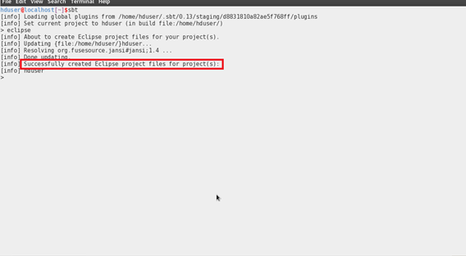

I am creating a folder named **Hadoop_app_sbt**and inside **src/main/java.**I have pasted the code of Hadoop word count program. The tree diagram is shown below

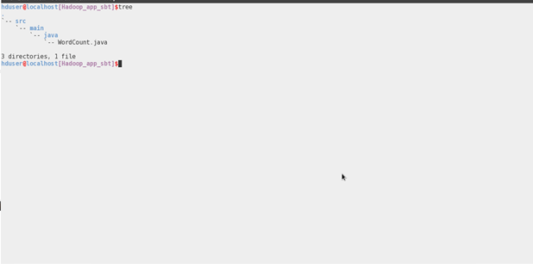

**Compiling the code and Building the Project:**

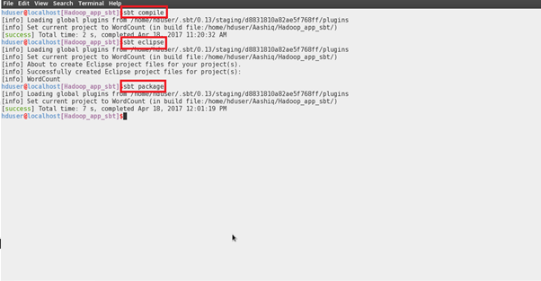

**Importing the Project into the Eclipse:**

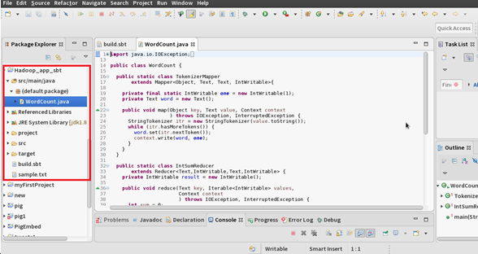

**Jar Created-Tree Diagram:**

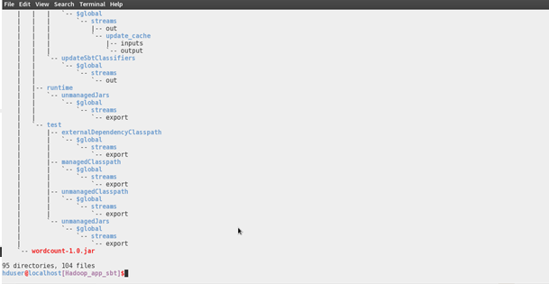

**Running the Jar File:**

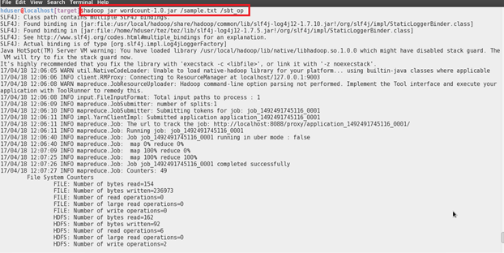

**Output of the WordCount Program:**

